43.66: a) After 4.0 min = 240 s, the ratio of the number of nuclei is
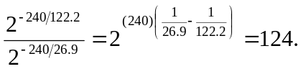
b) After 15.0 min = 900 s, the ratio is